* **Get a Track**

輸入歌曲ID

<https://developer.spotify.com/console/get-track/?id=3n3Ppam7vgaVa1iaRUc9Lp&market=>

複製artist ID、preview_url

產生SurveySong0531.csv檔

* **教學參考**

<https://medium.com/@rick.huang1609/window-10%E5%AE%89%E8%A3%9Dtensorflow-gpu%E4%B8%A6%E5%9C%A8jupyter-notebook%E5%92%8Cspyder%E9%81%8B%E8%A1%8C-221bb4707dbd>

* **安裝CUDA和cuDNN**

GPU版的TensorFlow需多加裝CUDA和cuDNN，先確認顯卡是否支援CUDA。

確認安裝環境：顯卡版本要先檢查

本篇版本：tensorflow-gpu-1.12.0、CUDA：v9.0 (cuDNN：v7.3.1) for window10 64bit

1. 創建資料夾

D:\ NVIDIA GPU Computing Toolkit\CUDA\v9.0

D:\ NVIDIA Corporation\CUDA Samples\v9.0

1. 選擇安裝版本與作業系統相符

下載CUDA，選Base Installer，<https://developer.nvidia.com/cuda-downloads>

【cuda_9.0.176_win10.exe】

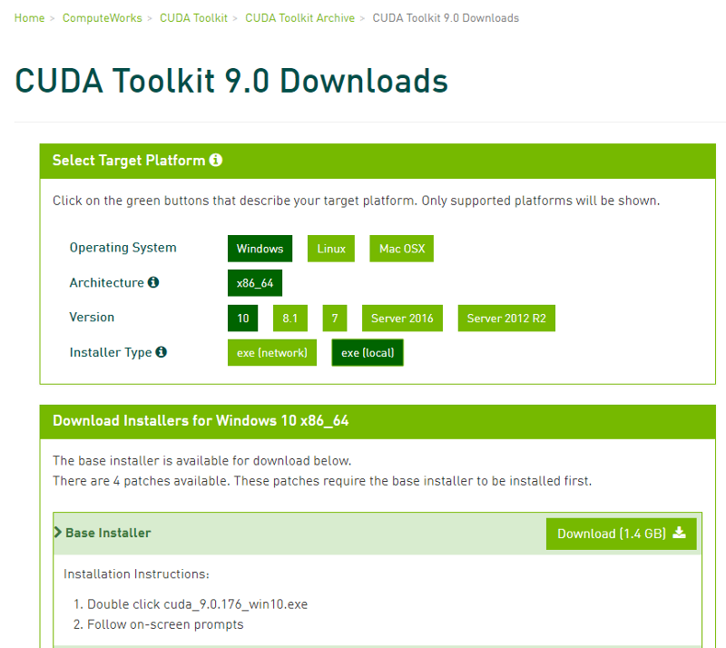

1. 下載cuDNN(申請帳號登入)，cuDNN v7.3.1 Library for Windows 10，<https://developer.nvidia.com/rdp/cudnn-download>

【cudnn-9.0-windows10-x64-v7.6.0.64.zip】

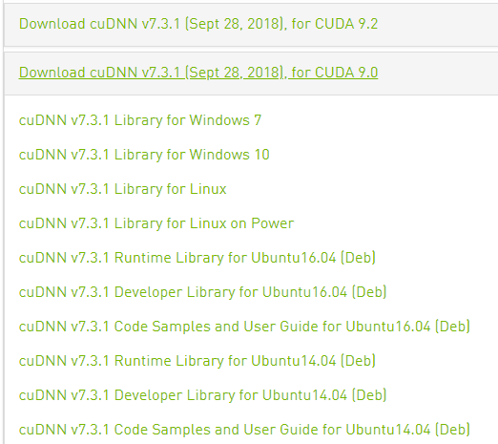

1. 覆蓋檔案

cuDNN解壓縮後，裡面有三個資料夾，將這三個資料夾複製到剛才安裝CUDA的資料夾覆蓋

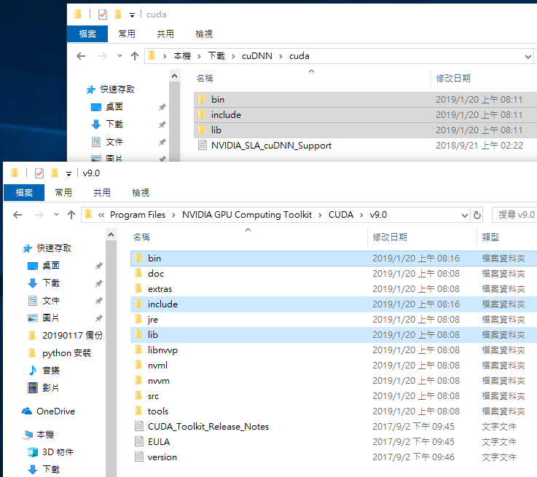

1. 安裝後新增系統變數

系統變數欄位 > 新增 > 輸入變數名稱(CUDA_HOME) > 輸入變數值 > 確定

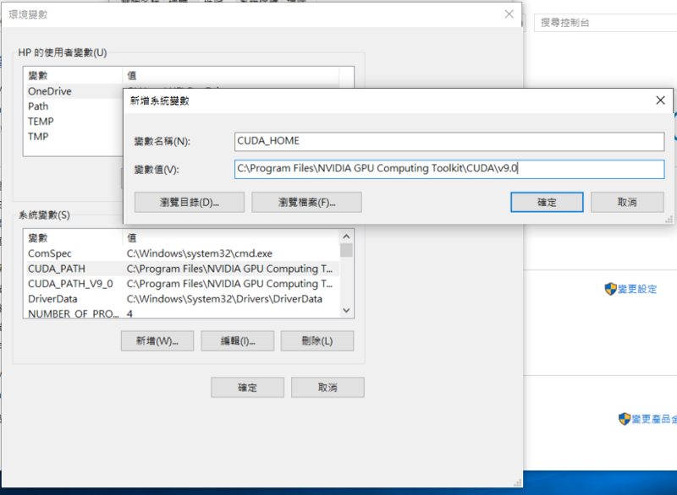

如已自動新增，就不用自行添加

D:\ NVIDIA GPU Computing Toolkit\CUDA\v9.0\lib

D:\ NVIDIA GPU Computing Toolkit\CUDA\v9.0\bin

1. 測試

建立CUDA test.ipynb

from tensorflow.python.client import device_lib

print(device_lib.list_local_devices())

或

import tensorflow as tf

hello = tf.constant(‘Hello, TensorFlow!’)

sess = tf.Session()

print(sess.run(hello))

* **下載magenta檔案**

You need have wavenet embedding pretrain model

<https://github.com/tensorflow/magenta/tree/master/magenta/models/nsynth>

git clone <https://github.com/tensorflow/magenta.git>

* **執行code**

<https://github.com/hyk3404/wavenet_embedding>

step 1 get the vector

python wavenet_embedding_vector.py

step 2 get the similarity

python cos_euc_output.py

* 網址下載mp3

1. 執行audio_download.ipynb
2. 建立test0531資料夾，放入SurveySong0531.csv檔
3. 修改with open('./test0531/{}.mp3'.format(name), 'wb') as f:
4. 修改audio = pd.read_csv('./test0531/SurveySong0531.csv')

* WaveNet嵌入

1. 執行wavenet_embedding_vector.ipynb
2. 修改path，dataset_path = './test0531' #dataset位置
3. 資料夾出現mp3對應的.npy檔

* 資料視覺化

1. 執行npy_to_tsv.ipynb
2. 修改path位置

file_list, file_names, folder_list, folder_name = file_path('./test0531', 'npy')

out_v = io.open('tsv/vecs0531.tsv', 'w', encoding='utf-8')

out_m = io.open('tsv/meta0531.tsv', 'w', encoding='utf-8')

1. Embedding Projector視覺化

丟入tsv檔

<https://projector.tensorflow.org/?fbclid=IwAR2DIgIT_nR5LTrsKddXfS90mQiz490wwwVtd-KXMTSv-wLC4ezEAuuTRCU>

* 距離計算

1. 執行cos_euc_output.ipynb
2. 修改路徑，path = './test0531'
3. 每個mp3都會產生兩份csv檔 ( _euc.csv & _cos.csv)

* 比較

1. 執行file_comparison.ipynb
2. 修改路徑

with open("comparison/comparison0531.txt", "w", encoding="utf-8") as txt: